Project 5

Step 1:

I created the first EC2 instance and I updated and upgraded the instance.

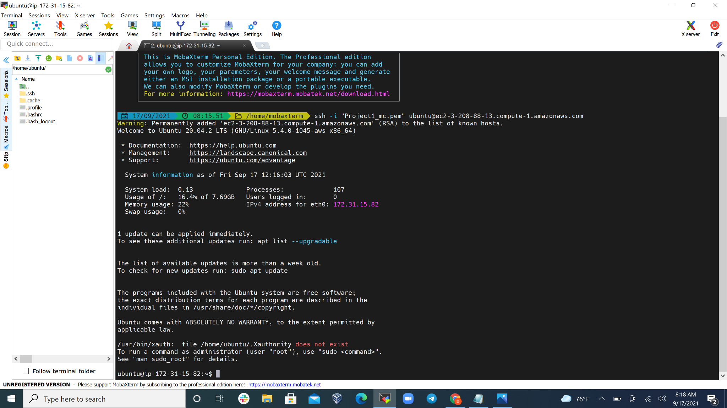

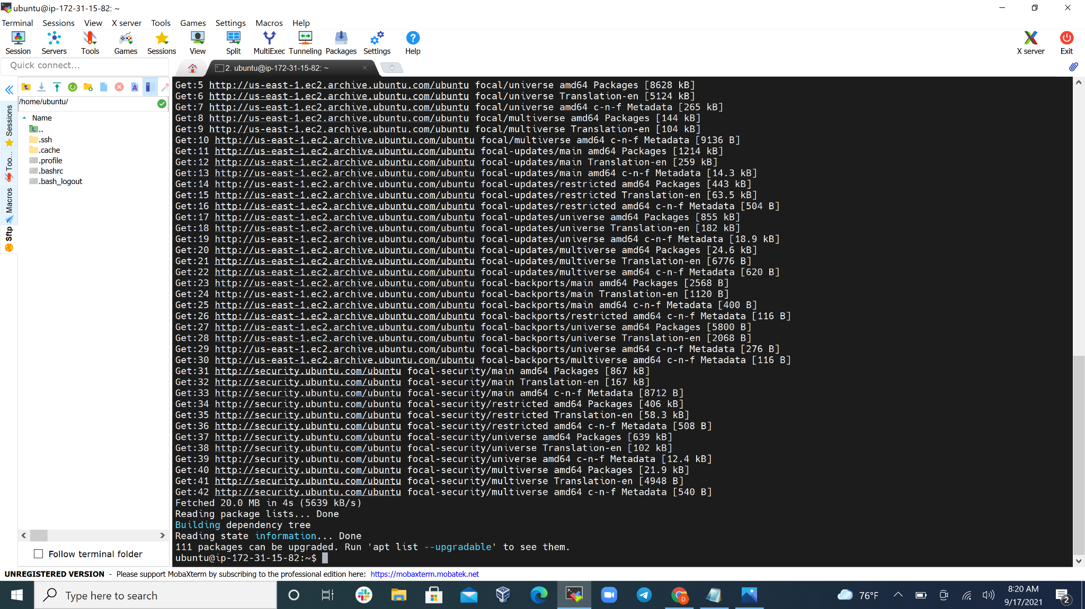

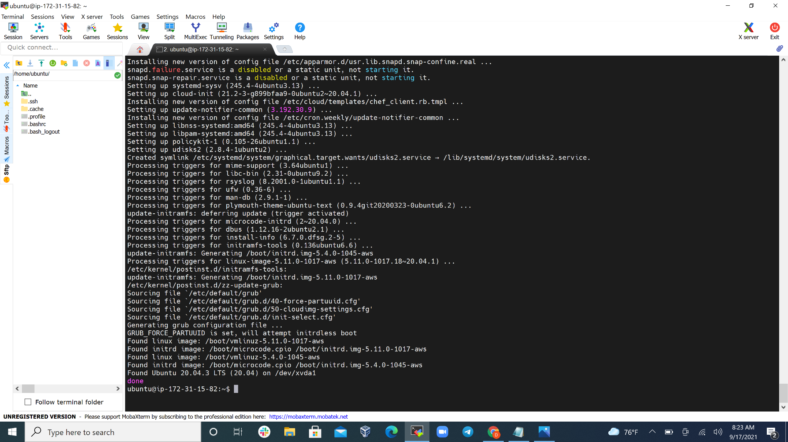

Step 2: I installed mysql-server on the first instance.

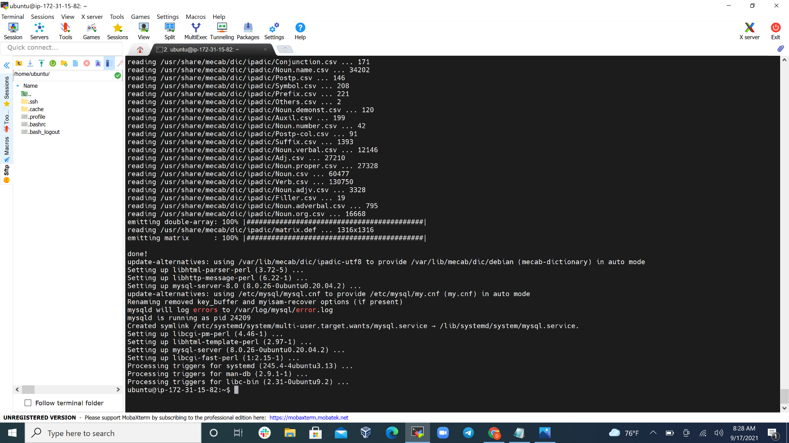

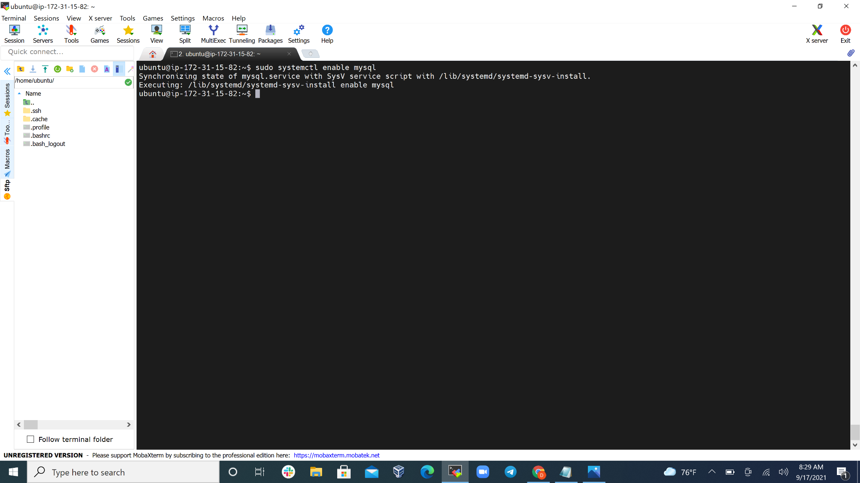

Step 3: I created a second EC2 instance and I updated and upgraded it. Also, I installed mysql-client on it as well

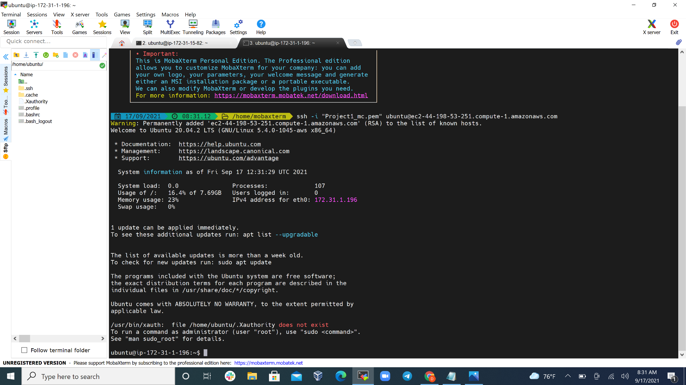

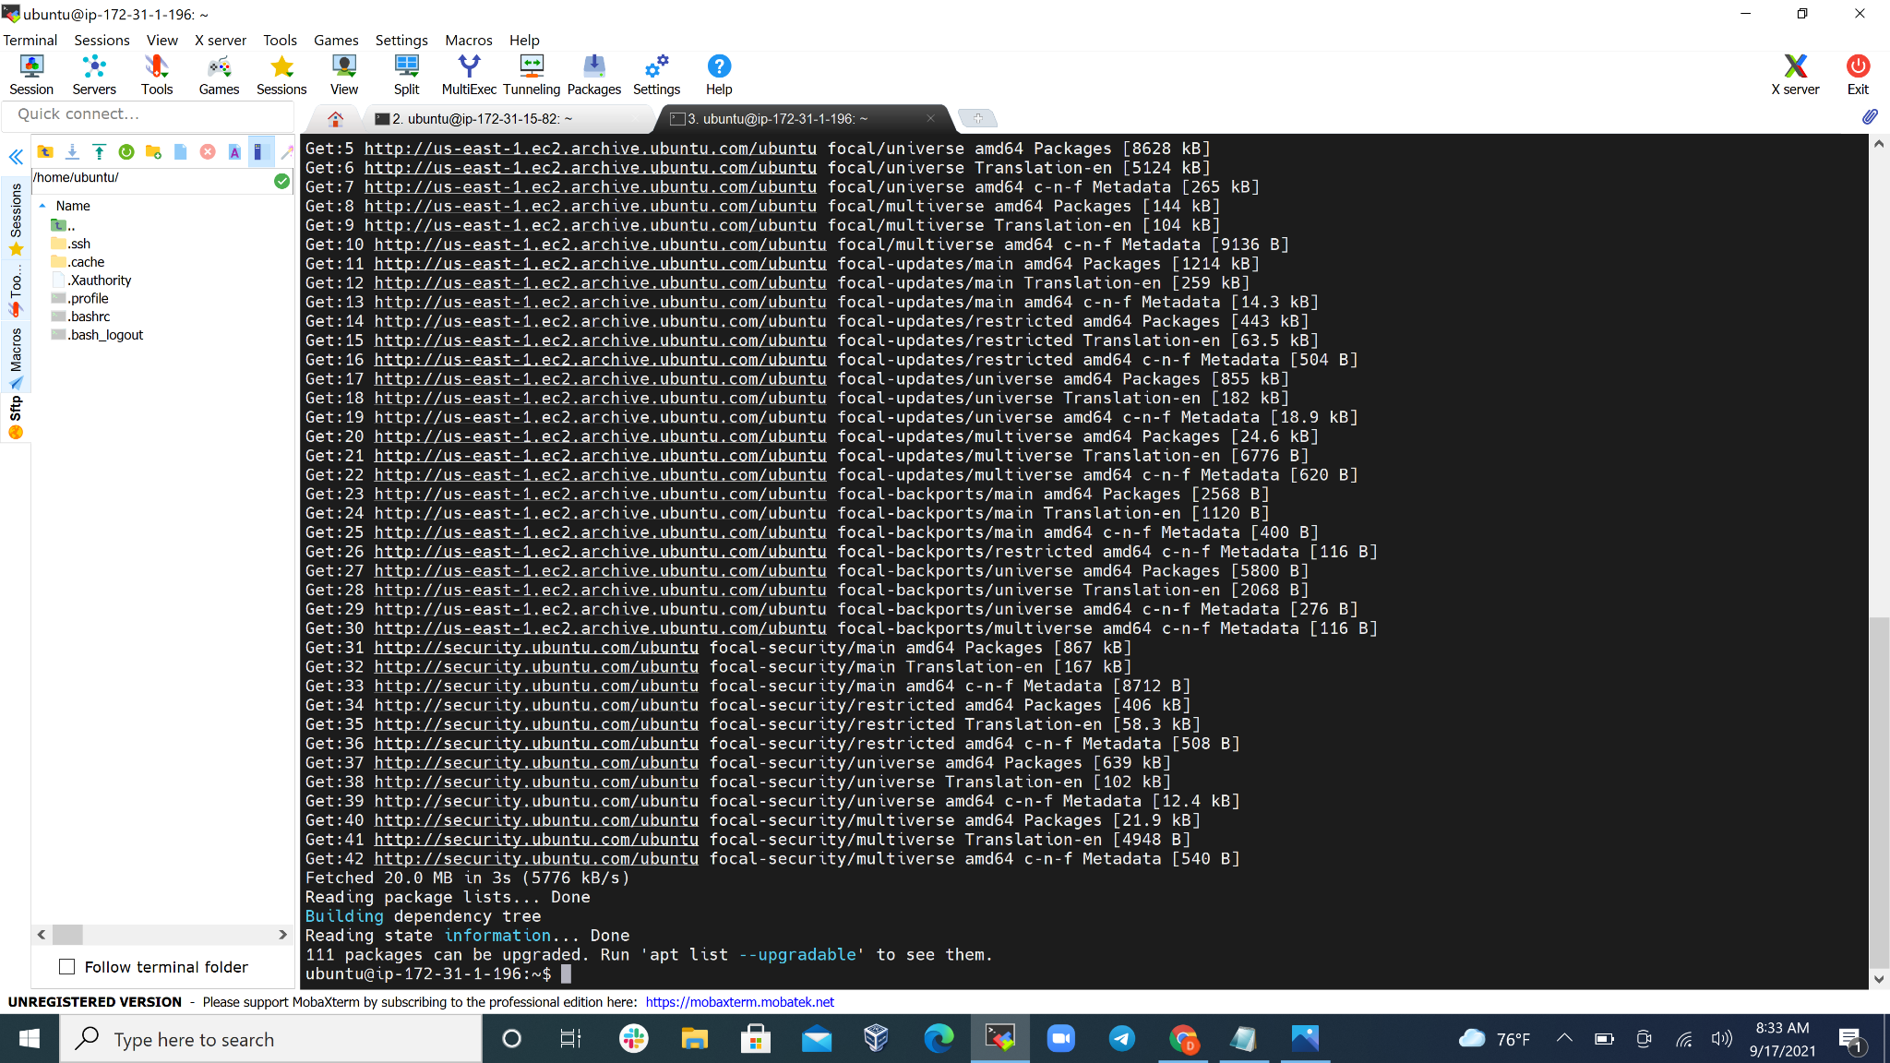

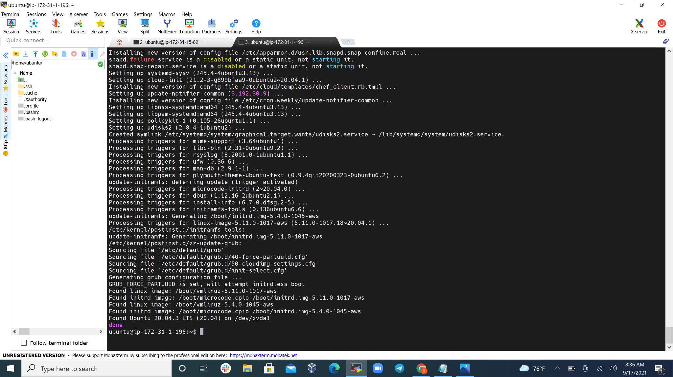

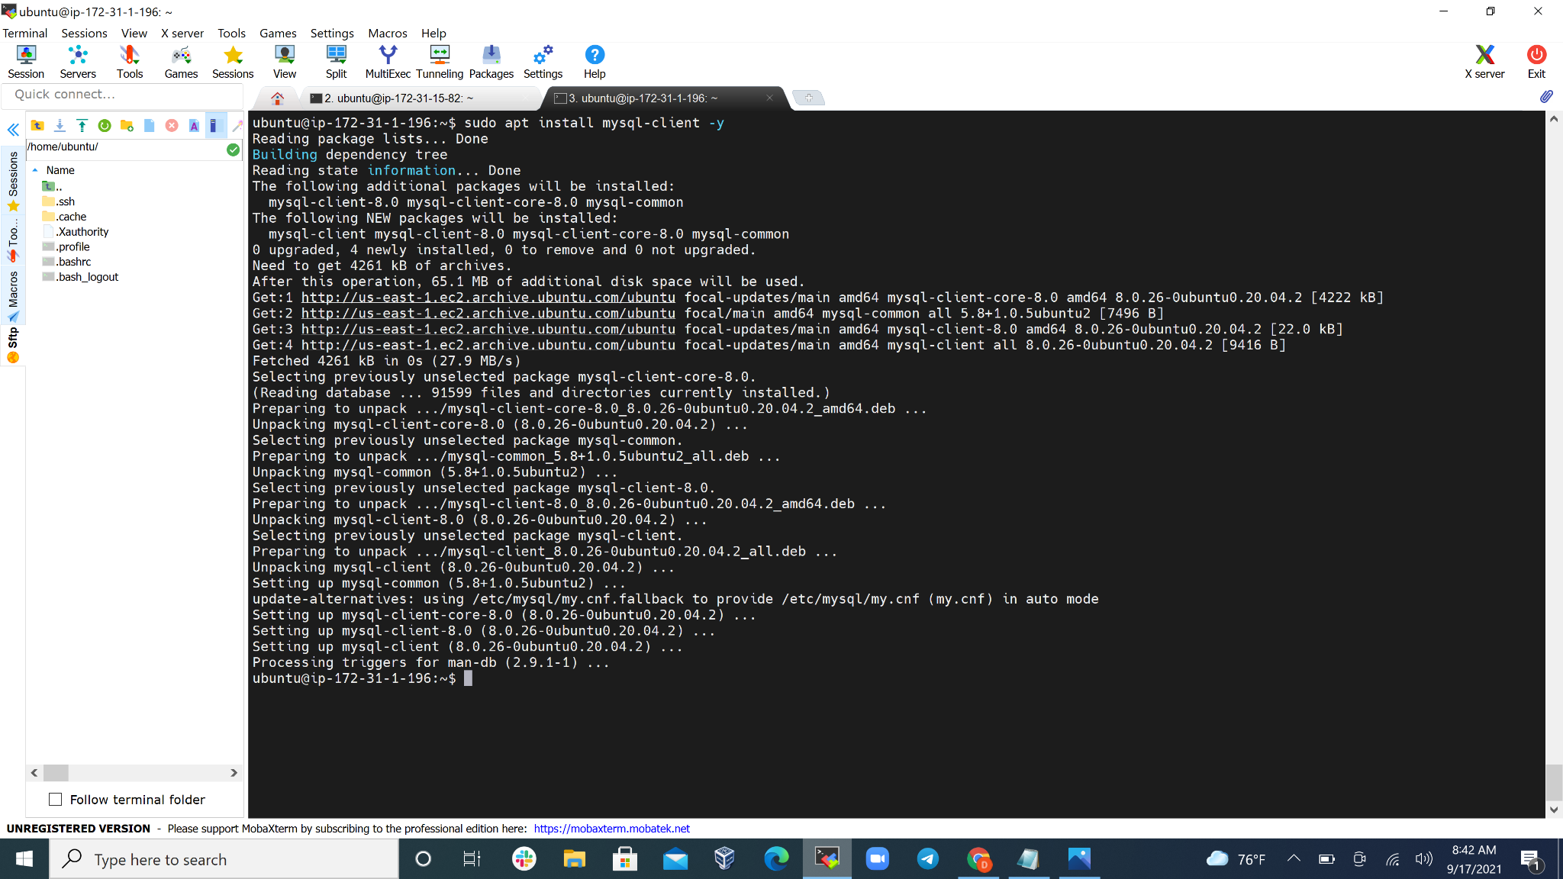

Step 4: I viewed my ip address on my client-based instance and I edited my inbound rule on mysql-server based EC2 instance.

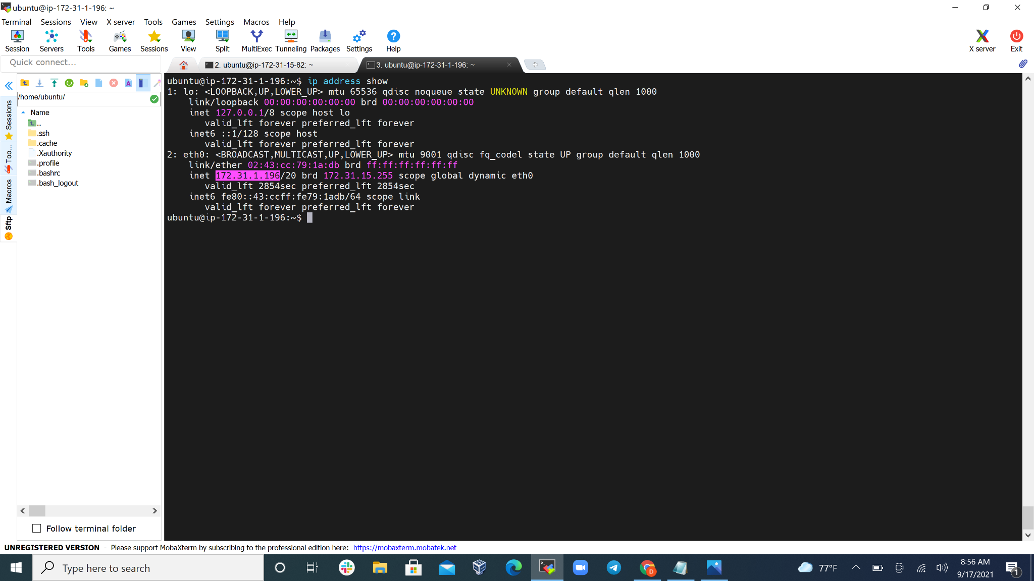

Step 5: I ran **sudo mysql_secure_installation**  to create a proper environment for my sql on the server-based EC2 instance

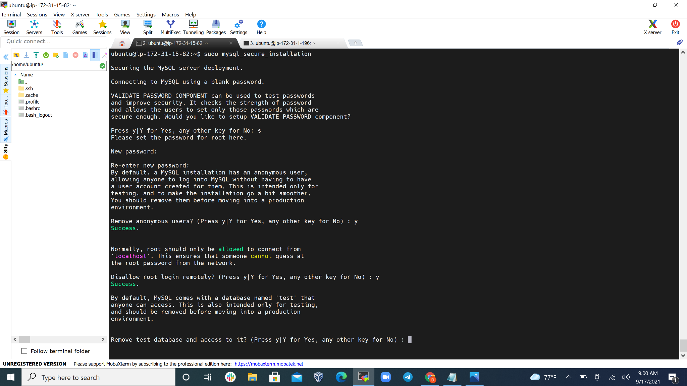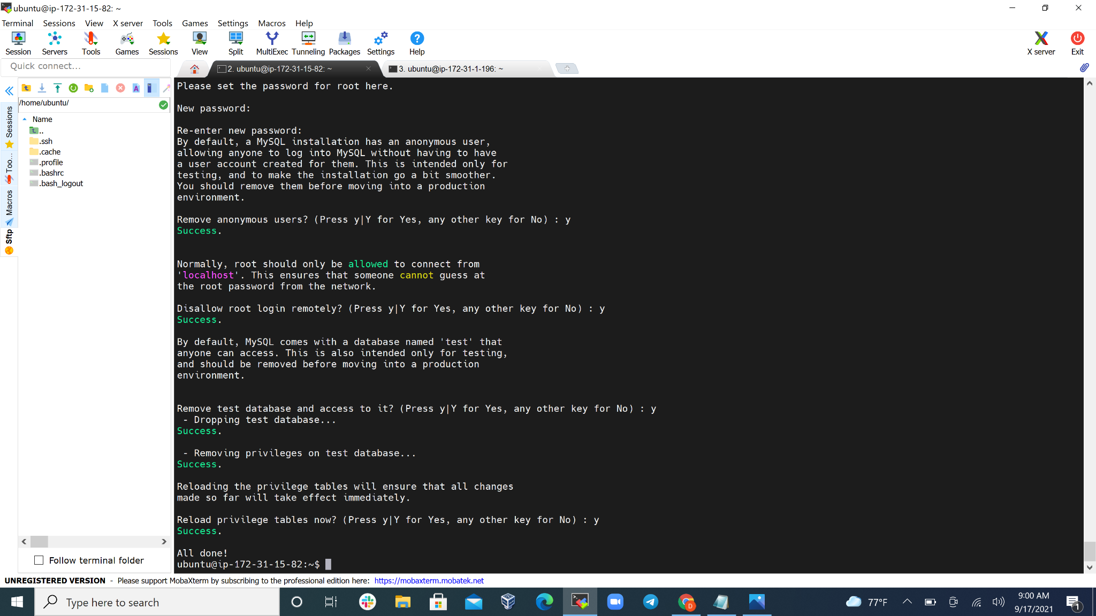

Step 6: I ran **sudo mysql** to enter into the mysql environment

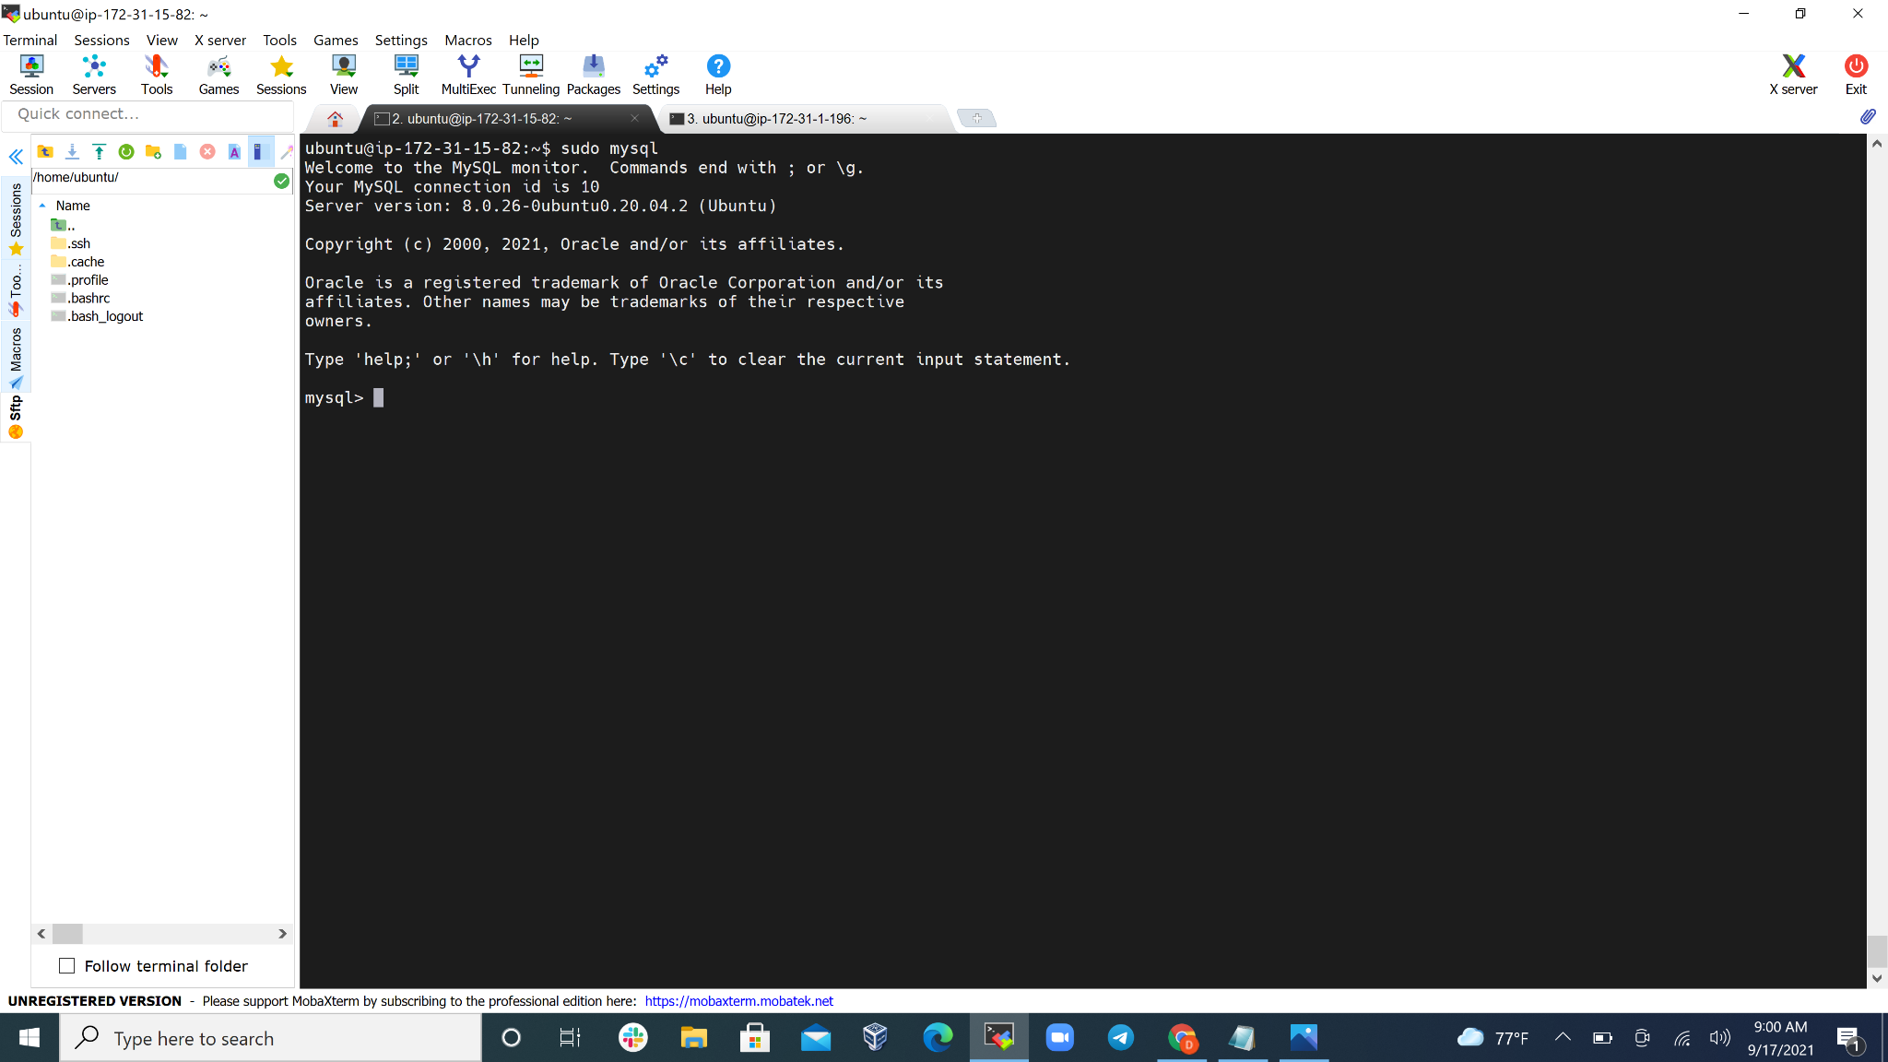

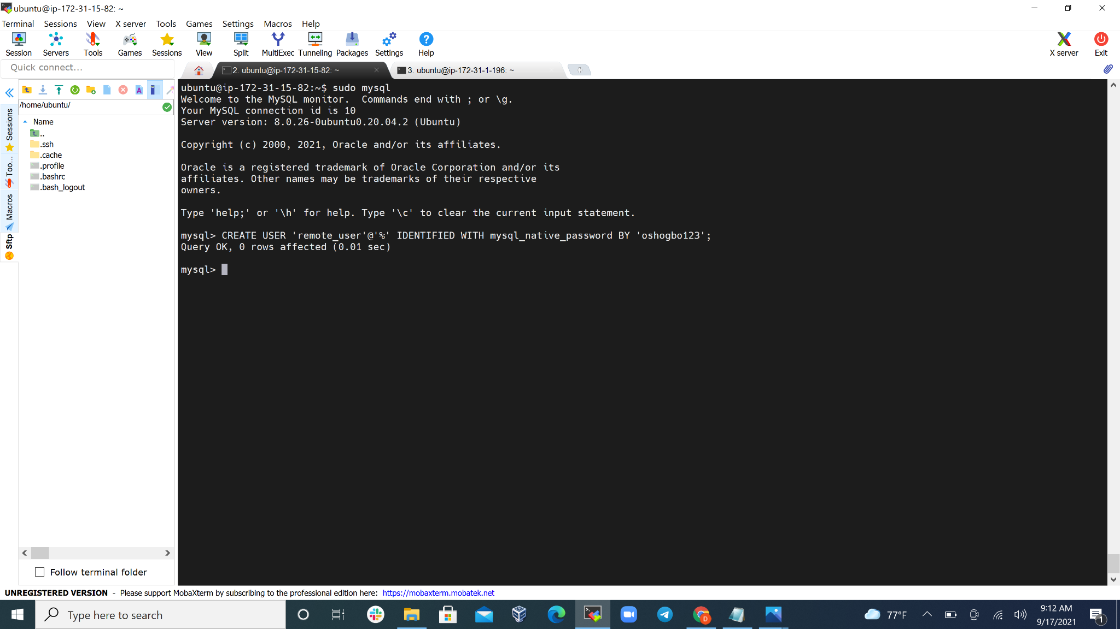

Step 7: I ran all the necessary lines of code in the mysql environment as directed

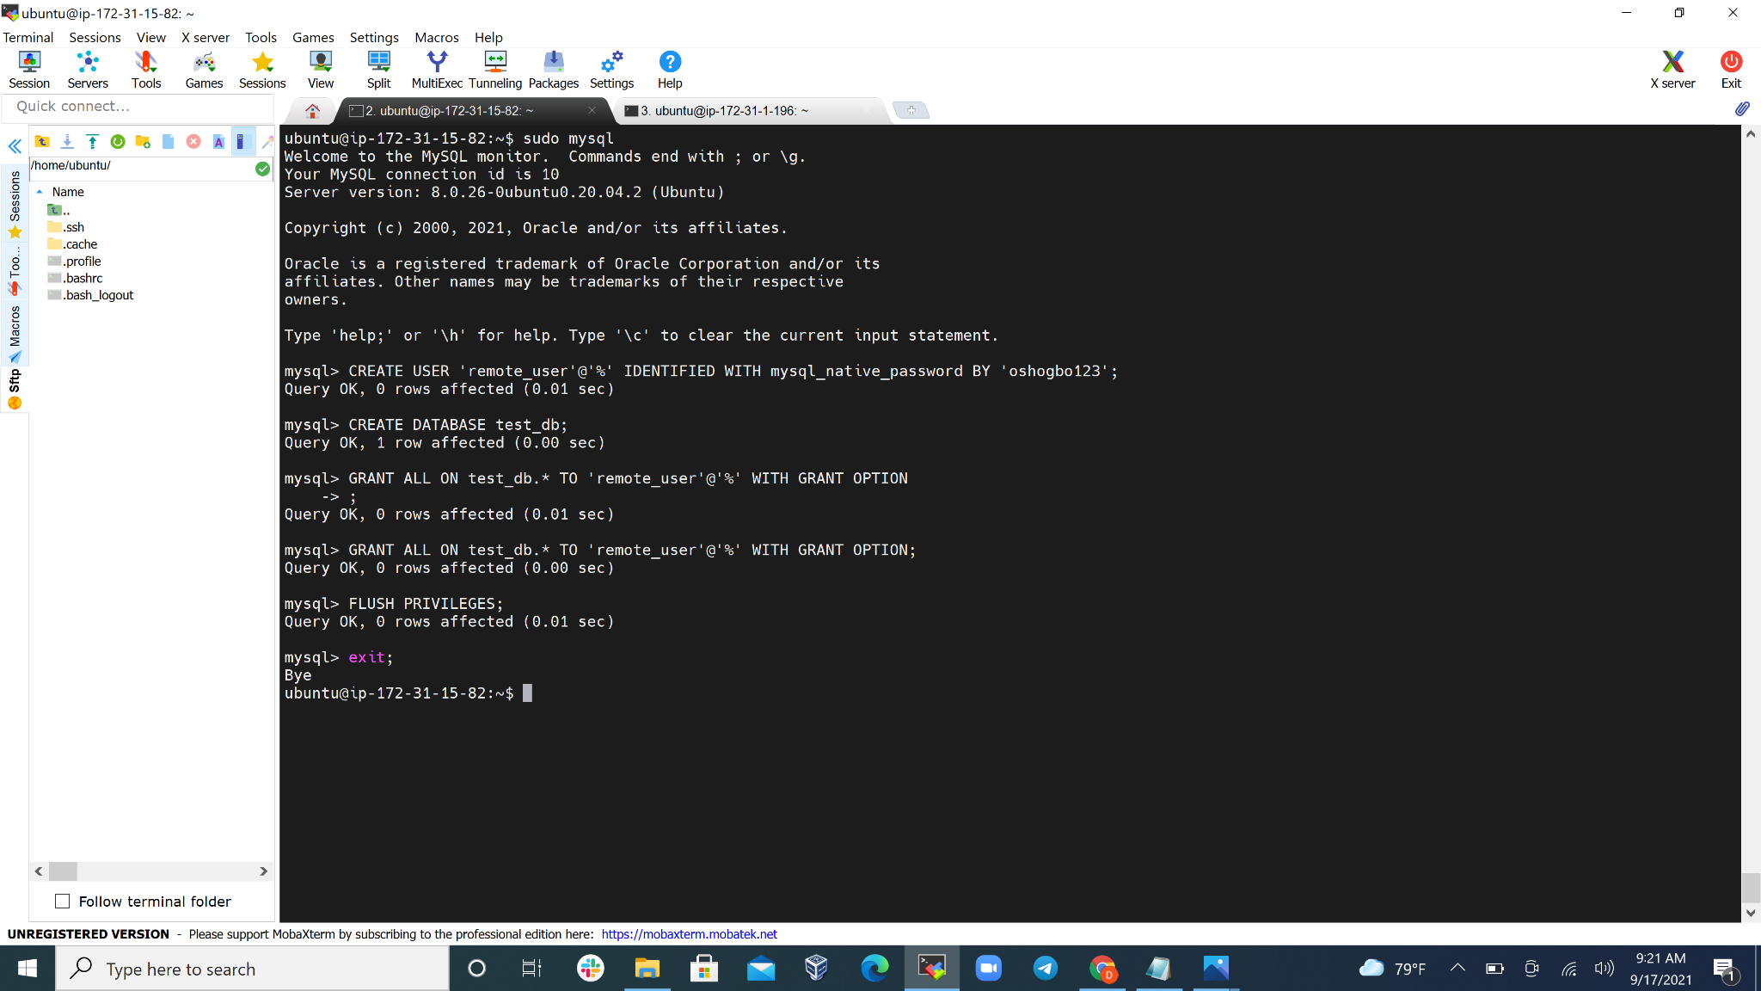

Step 8: i edited the mysql.cnf file and changed the IP to my public IP and i restarted the mysql service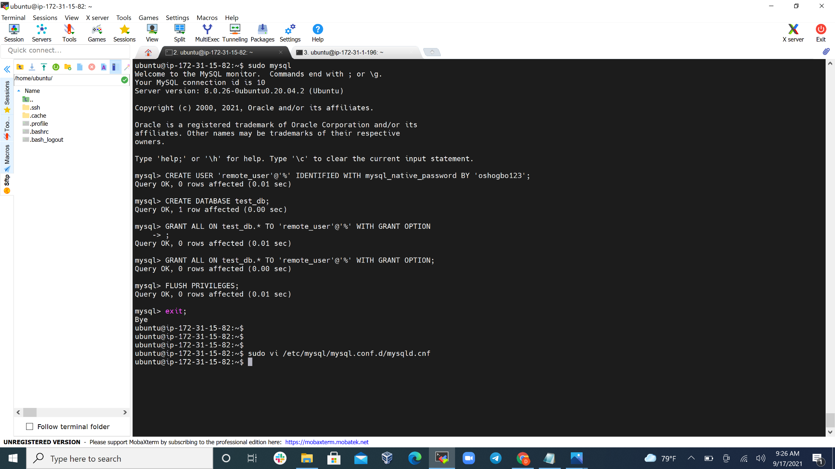

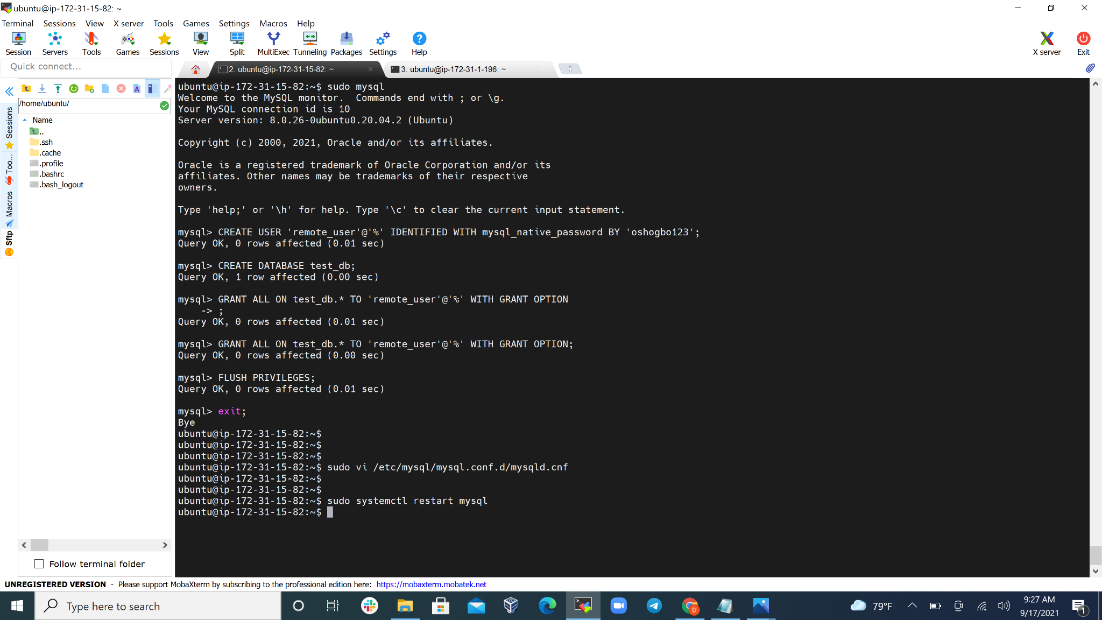

Step 9: I went to mysql client EC2 instance and used **sudo mysql -u remote_user -h <public_ip> -p** and i typed **show database** which confirmed that my “**test_db”** database has een created.

